**Project Team 27**

Sprint #1

Week #1

Team Member Name – Swapnil Makarand Joshi

What I did since the last week scrum?

1. Installation of JMonkey and Blender
2. Understand file structure of Jmonkey project
3. Learn some basic through demo tutorial like rotation, transition, 3d object view,

Keyboard activity

What I plan to do next week?

1. Learn remaining basics through demo tutorial like blender 3d object creation, sound effect, Animation effect
2. Start to learn keyboard and mouse activity in details

What blockers I have?

None

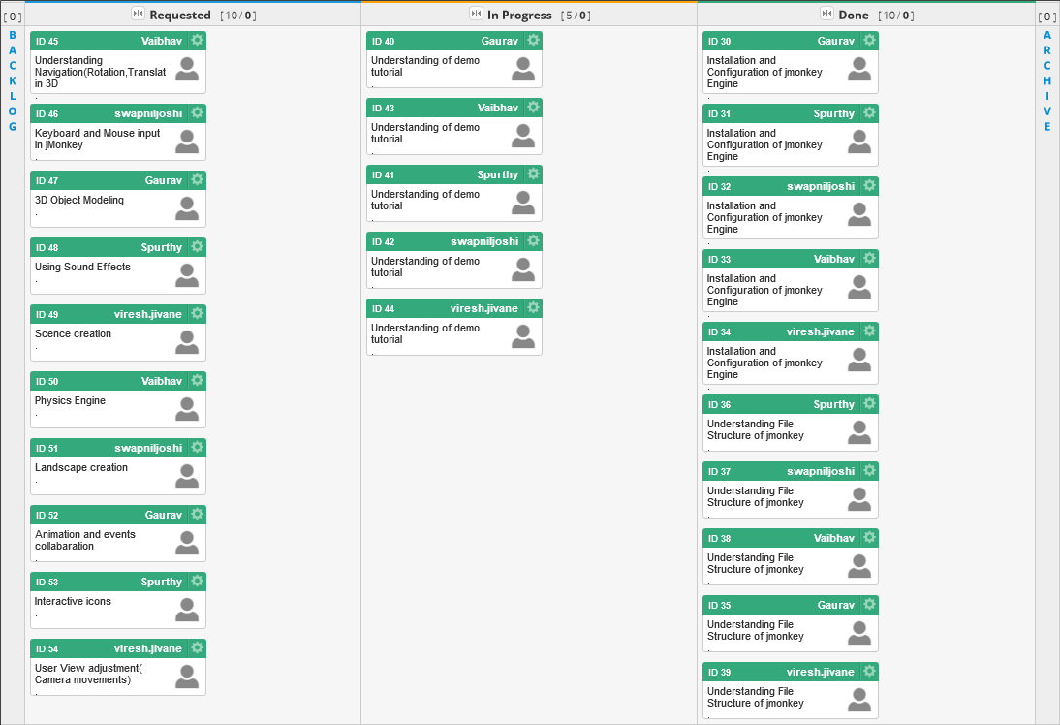

Task board in Kanbanize

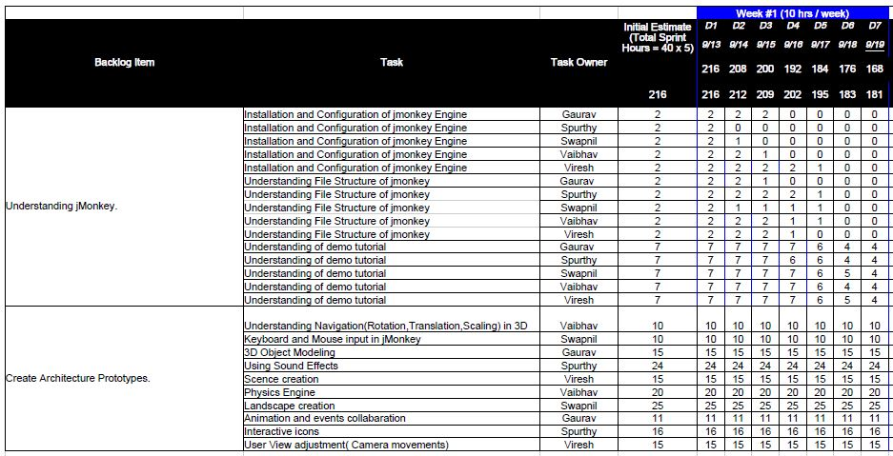

Weekly Standup Report

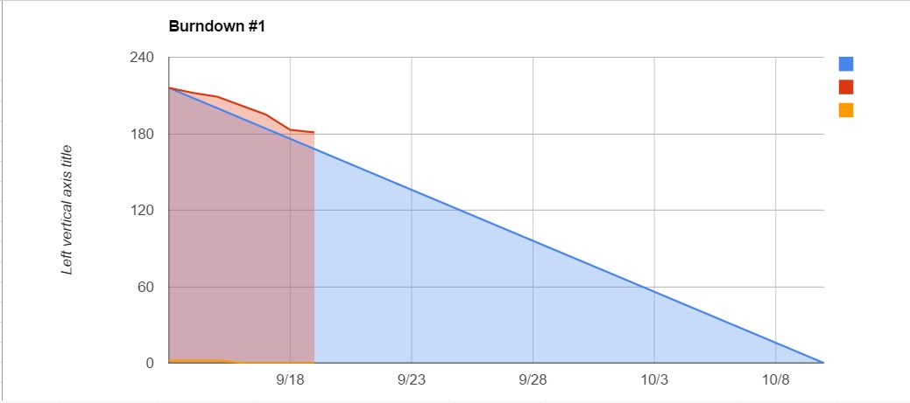

Burndown Chart